Low Level Design (Login Module)

Project Code | Team3
Project Name | Hotel Management System

Prepared/Modified by | Role | Date of Preparation
Reviewed by | Role | Date of Review
Approved by | Role | Date of Approval
 | Training Manager
Circulation List |  | Version Number of the template:1.0
Version Number | 1.4

Table of Contents

1. Description Of The Unit 3
2 References 4
3. Dependencies / Assumptions 5
4. Class Diagrams 6
5. Sequence Diagrams 7
6. Design Components 8
a. List Of UI Components 8
b. List Of Design Classes 9
7. Re-Usable Routines/Components 10
8. Messages 11
9. Configuration Files 12
10. Data Mapping 14
11. Action Flow Matrix 15
12. Stored Procedures 16
13. Program Specification / Pseudo Code 17
REVISION HISTORY OF THE WORK PRODUCT 19

Description Of The Unit

The login module allows the admin of the application to login into the system using their valid credentials.

The Id and password entered by the admin is validated from the database. If the entered credentials are valid then he/she is redirected to the respective page. Admin is redirected to Admin Page where options are provided to add, delete or update a Hotel or Room and view various reports.
If the entered credentials are invalid then he/she is redirected to the login page and an appropriate error message is displayed.

2 References

Reference | Description
Repository reference | https://IGTEBLRSVNTNG.igatecorp.com/svn/oct3_Team1
Class Diagram | /Project Documents/Design Documents/HLD/Class Diagrams
URS | /Project Documents/Requirements/Case Study/Ecommerce-grp1 and grp3.doc
UTP | /Project Documents/Test Plan/UTP/Test Cases/Login Module/UTP_LoginModule.xls
DB Design | /Project Documents/Design Documents/HLD/DB Design/E-Commerce_GROUP_DBDESIGN.xls

Dependencies / Assumptions

Dependencies:
This module is not dependent on the any module. The admin details are taken from the form and checked from the hard-coded values given in the controller.

Assumptions:
UserId and password of the admin are described in the controller. It is assumed that Admin/Hotel manager valid credentials already exists in the database.

Class Diagrams

Class Diagram
N/A

Sequence Diagrams

Sequence Diagram
N/A

Design Components

List Of UI Components

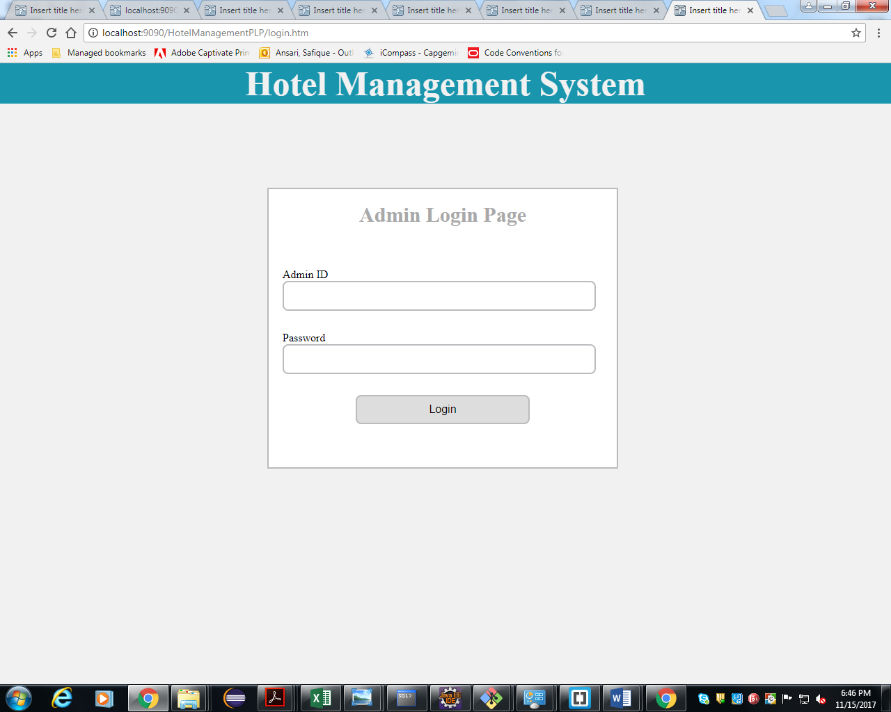

List Of Design Classes

Sr. No. | LLD Name | Class Name | Method Name | Method Description
1 | Login Module | HotelController | Public String checkLogin(@RequestParam("id") String id,@RequestParam("password") String password, Model model) | Takes values from the Login form and then checks the credentials ,  authenticate the role and then it redirects to appropriate Pages based on the role of the user.

Re-Usable Routines/Components

Re-Usable Routines/Components

- CSS files
- UI files
- Database properties files
- Logger properties files
- Constant interface
- QueryMapper interface

Messages

#. | Type | Message Text
M1. | Error | Invalid Id or Password!!!

Configuration Files

File Name | Path | Description
oracle.properties | /Development/Source | To configure database connection.
Web.xml | /HotelManagementPLP/WebContent/WEB-INF/ | To configure the bean properties.
Dispatcher-servlet.xml | /HotelManagementPLP/WebContent/WEB-INF/config/ | To configure the request mapping and view resolver.
jpaContext.xml | /HotelManagementPLP/resources/ | Add persistance annotation bean post processor to inject persistence context into entity manager factory

Data Mapping

Data mapping in our project is done in HotelController java class. Values for Admin ID and Admin Password are fetched from Login form and they are matched with the values given in HotelController’s “checkLogin” method. If the credentials match then the admin is directed to next page according to his role.

Action Flow Matrix
Sr. No. | Action | Description | Process
1 | On click of Login Button | Valid Admin gets logged | Id and Password is validated from the database. If admin is valid he/she is directed to respective Pages based on the role.Admin is redirected to Admin Page where he can add,delete and update hotels & rooms, also view reports based on various conditions.

Stored Procedures

# | Stored Procedure Name  (with Description) | Input/Out Parameters | Type | Size
1. | NA | NA | NA | NA

Program Specification / Pseudo Code

13. 1 <ACTION: ONPAGE_LOAD>

Pseudo Code:

- Client Side Scripting
None
- Server Side Scripting

BEGIN
Call checkLogin(String id,String password,Model model) function in HotelController class which navigates to Login Page on successful check.
END

13. 2 <ACTION: LOGIN_CLICK>

Pseudo Code:

- Client Side Scripting:

IF Id isEmpty
Print Error Message M1
IF Password isEmpty
Print Error Message M1
IF invalid Id
Print Error Message M1
IF invalid Password
Print Error Message M1

- Server Side Scripting:
BEGIN
Call checkLogin(String id,String password,Model model) function in HotelController class in Presentation Layer
END
if ("System".equals(id) && "Capgemini123".equals(password))
return "Admin";
BEGIN
Call addHotel(Hotels hotelDetails) in HotelServiceImpl in Service Layer
BEGIN
Call addHotel(Hotels hotelDetails) in HotelDAOImpl class in Service Layer
BEGIN
Persist Hotel Details by using entitymanager object
END
Return role to EshopBOImpl
END
Return role to HotelController class
Navigate to respective pages according to various actions
Else navigate to login page
END
REVISION HISTORY OF THE WORK PRODUCT
# | Date | Version # | Section Changed | Details of changes made | Approved By
1 | 16/12/2013 | 1.0 | Document prepared | N/A | Uma M Ponniamman
2 | 17/12/2013 | 1.1 | List of design classes  Data Mapping Matrix | The controller’s name is changed to “EshopController”  Change Password field added | Uma M Ponniamman
3 | 18/12/2013 | 1.2 | Reusable components,  References,  Data Mapping Matrix. | Reusable Components added.  File name with relative path is added in the references section.  The name of text boxes(screen label is changed). | Uma M Ponniamman
4 | 20/12/2013 | 1.3 | Messages | Changes made in Error Messages | Uma M Ponniamman
5 | 24/12/2013 | 1.4 | Configuration files,UI Components | Paths of the configuration files is updated and UI components(Screen Shots) added. | Uma M Ponniamman

